Name:  Class: | ____________________________________  ________________ |  | Date:_________
 | Year 7 Mathematics  Mini-Test 4, 2018  Topic - Fractions |  | / 26  %
Total Time: | 30 min
Weighting: | 5 %
Equipment: | Page of notes (NO CALCULATOR)

Question 1 5 marks
Match the definition on the left-hand side with the correct word on the right-hand side by drawing a line between each one:
A fraction where the numerator is equal to, or larger than the denominator. |  | Improper fraction
A fraction consisting of a whole number and a proper fraction. |  | Denominator
The top number in a fraction. It shows how many parts we have. |  | Proper Fraction
A fraction where the numerator is smaller than the denominator. |  | Mixed Number
The bottom number in a fraction. It shows how many equal parts the item is divided into. |  | Numerator

Question 2 1 mark
What fraction of this shape is shaded? Put the answer in its simplest form.
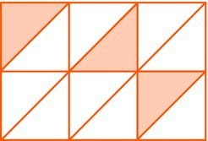

Question 3 1 mark
Using the following diagrams colour in two fractions that are equivalent to each other.

Question 4 8 marks
- Write the fractions marked by a dot on the number line:

- Write the following fractions from smallest to largest:
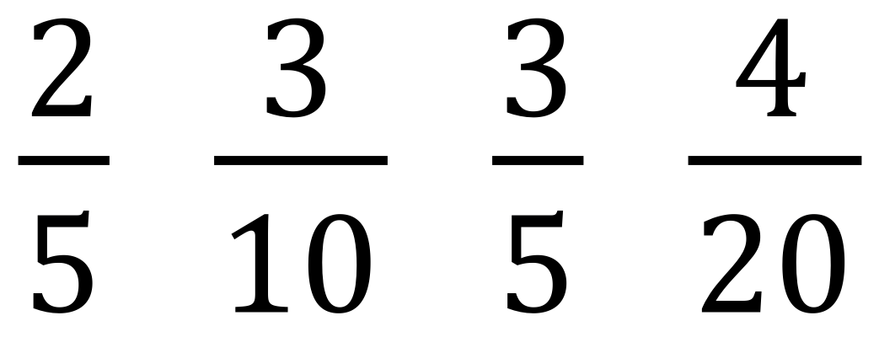

Question 5 11 marks
Evaluate the following. Make sure to leave all answers as proper or mixed fractions. If possible, simplify your answer.
